**PROJECT DESCRIPTION***Create a proposal for the Final Website Project that explains the topic, purpose, goals, target audience(s), description of the site and business, organization, testing, security and search engine optimization/marketing.*

**Note: Please read through all this in its entirety to understand what is required in Project 4: Website Creation**(Hint: you will need this information to do the Project 2).

The goal of the website project for this course is to demonstrate your ability to apply the skills you have learned during the term by creating a real-world website project. The main purpose of the project is to learn to conduct good project planning, including development of website marketing strategies (e.g., search-engine optimization) and identifying performance and security risks. As part of proper project planning, best practices dictate the use of a proposal for establishing the requirements of a website’s design. Therefore, students will submit a proposal/plan for website creation. Project 2 topics must be approved by the instructor and then you will create a full-functioning website in Project 4.

**Overview**For this project, you will create a proposal/plan in Project 2 and then in Project 4, build out the website you proposed. It is important to think about what will comprise the 10 pages - colors, fonts, images, target audience, content for pages, etc. Each criterion in the grading rubric should be carefully considered when creating this proposal in order to achieve the highest grade. The website must contain a minimum of ***10*** newly created HTML5 web pages (not including files, such as .txt, .js, or .css). Your website must be original work created during this term and cannot have been previously created for any other purpose, including pages created in previous projects for this course. Your Project 4 can be a website designed for your workplace, nonprofit/volunteer work, or another business/organization, real or fictitious. Hopefully, the project will be something of benefit that you can take away from this course.

Examples of student projects include, but are not limited to the following:

* a website for your department at work (no intranet sites)
* a website for your entire company
* a website for your favorite nonprofit organization
* a website for a home-based business you run
* a website for a business someone else owns
* a website for a portfolio of your (or someone else's) work

** PROJECT REQUIREMENTS  
For Project 2, create a well-designed proposal that addresses the following questions, in order:**

1. **Client and Topic (25-word minimum):**Which of the following describes the website you will be creating? website (*you must seek instructor approval*).
   * My plan to do a website based off of my best friend that is starting his music career. To show case photos, videos, blog, social media and more. This will be a starter site; I plan to make it modern looking. Hip hop/rnb genre
2. **Development Process and Engagement (50-word minimum):**
   * **Are you making the website for a client (someone other than yourself?)**

I will be making it for a friend/client, to help start up his music business.

* + **If you are making the website for a client, how will you involve them in the development process?**

I plan to ensure from pre-planning and web-site testing I will show the client the process and take edits/suggestions on how to edit the site throughout the process.

1. **Testing :**

For the testing phase, I will need to ensure the site will be functional for all size screens, ensuring various platforms can view the site. Browsers that will be tested will be Chrome, Safari, Internet Explorer and Firefox. Additionally, ensuring the website is mobile friendly and translates correctly to apple, windows, and Android products. Once the site is made and I feel the compatibility with browsers and screen sizes all function properly, I will ensure outside users test the website out with feedback.

1. **Description:**

The business is mainly to promote a music artist. Goal would be to increase customer base views, music plays, and get to know who “Lil Walt” is through this website.

The purpose of this website will be share awareness and promote music, photos, tour information. Having links to share his YouTube videos while having a blog page can help him show where he comes from and background information.

* + The intended target audience would be ages from 16 to roughly30 years of age on average. Within this, females might be the majority with males the less majority by gender. Ethnicity, will vary since hip hop has been growing, although location would be mainly, USA, Canada, and most of the inner-city locations. This is where Hip hop and RnB genres are more favored. Education would vary although Middle school to College level will be more targeted.
  + The impact of the target audience is major. The style choice of the web pages is a big deal. Since most of the audience should be withing their 30;s and younger, These are the tech savoy generation and prefer modern style pages. Colors to pop out as well.
  + **What unique content created and/or written/designed by you (text, images, etc.) will the website offer?**

I am unsure at this moment what unique will be created by me, although the text will be unique and through communication back and fourth more text will be generatic and not fake fill in text. Additionally, cover IMG for his Music photos will be edited by me in InDesign program. Lastly, basic photos shot from him will come by me. Not all photos I plan to use will be sourced from a third party.

For the video sources I am thinking of using code from YouTube to have auto-play. If I use some third-party sources such as photos I will get them from a copyright free website for the web. Lastly depending on the font, I will use, I may go to google fonts to use fonts.

The site content would only need to be updated based on released songs, tracks, tour dates or uploaded music videos. I would say once monthly at most.

1. **Growth and Maintenance (50-word minimum):**
   * **How do you think the website will continue to grow and evolve over time?**

The style of the site might change to adapt with the times, the content this music artist produces will need to be updated and changed. Once I learn more, I would recommend making the site more interactive to others to ensure it is engaging.

* + **What things can you do while developing the website to make it easier to maintain?**

Ensure I am organizing my folders, files, CSS and Java properly. Using Visual Studio Code, there is a “Live feature” In which I can visual see all my changes and updates on the site, as I type in my code. This lets me edit and maintain the site easier, without having to go back and fix bugs and errors while developing.

* + **What tasks will be required to maintain the website?**

Some items I would say is, for blog section, try to add more content to encourage SEO traffic. I would need to check for any broken links from time to time. Ensure load speeds and figure out if something is slowing it down, Lastly, test my site within other displays to ensure all devices and browsers see the site correctly, such as the images are loaded.

* + **At what frequency will each task you identify need to occur? (e.g. daily, once a week, once a month, etc.)**

The frequency these tasks should depend. Although Adding blog information weekly or monthly. Checking broken links, and checking run speed would be monthly. Lastly Checking devices and display sizes are proper and META site according to best SEO effective will be quarterly or a bit sooner.

1. **Organization (100-word minimum):**

The website I am thinking should be modern looking. Have a modern Nav bar (Hamburger) drop down. Bold text and photo for home page, with a scrolling screen.

Sub topics, will be showing his songs, videos, Blog site, tour section for any tours if possible.

The pages I am currently thinking of is: Home, Photo, Video, Music, Tour, Blog, social media links in the footer, considering a sign-up forum to they can get alerts via email.

Home Page IDEA:

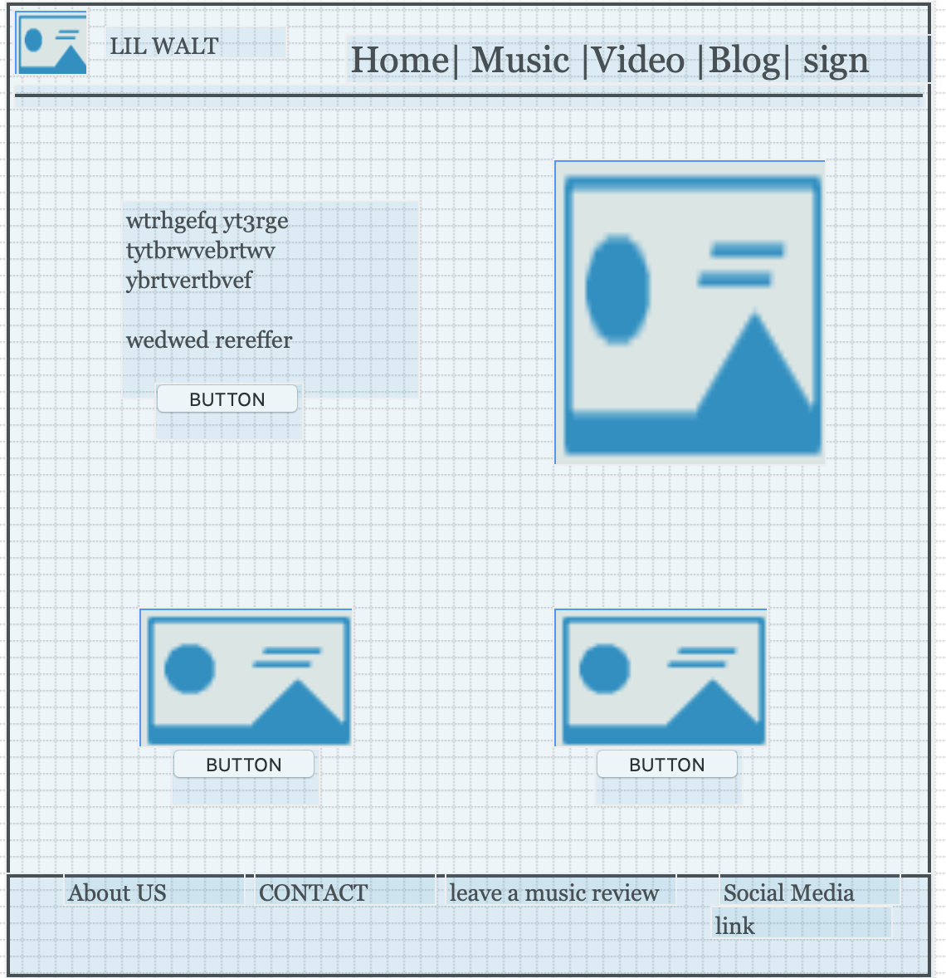

Photo Page (Mobile size):

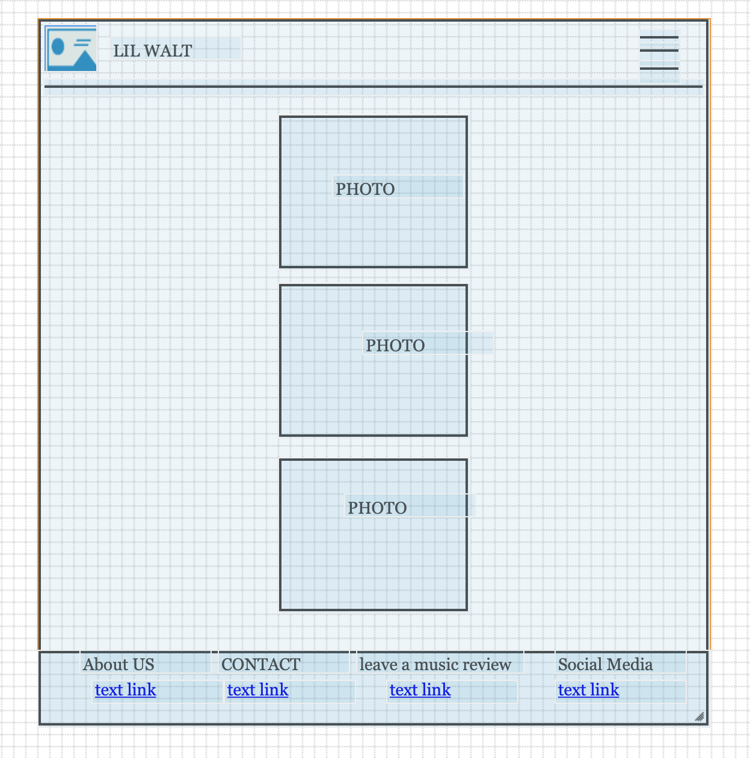

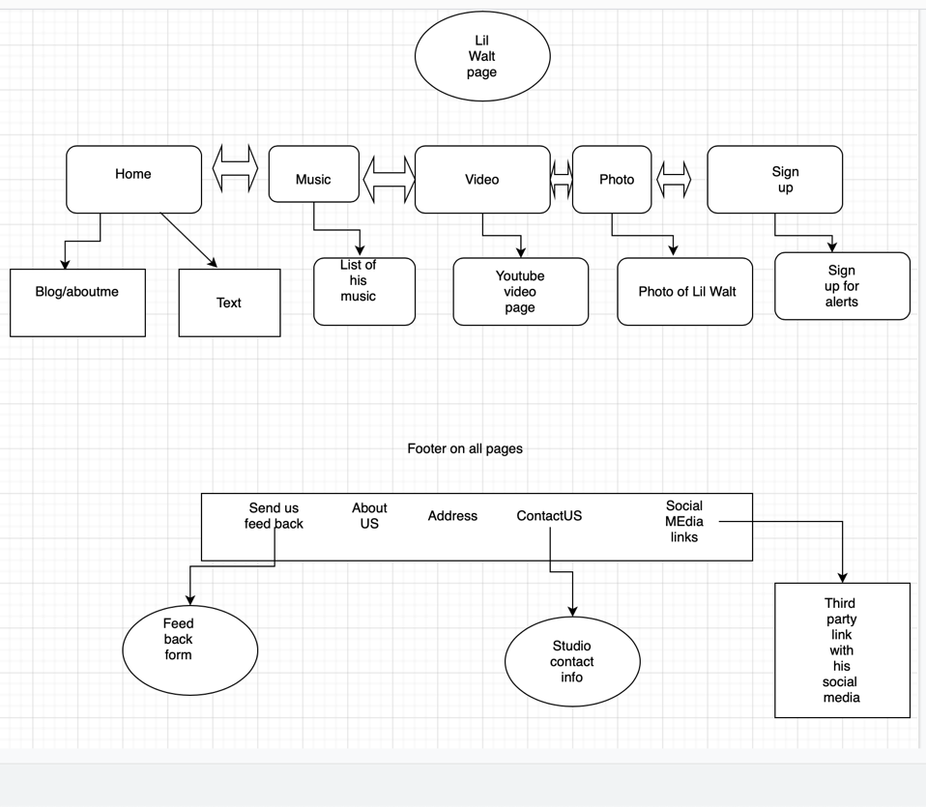

I may not be the best at using online app for story boarding; Although the Nav bar will have links that can be easily used to go back and forth through. The home page should have two main links to click on using buttons. The footer which should be used in the entire project will have clickable links; linked to an HTML5 page for “ Feedback, Contact info”. One Link will be attached to a third party page I would need to create. This third-party site such as “SmartURL”, This can be used to promote all social media platforms and music platforms easily. The other links in the NAV bar will have their own Webpage.

1. **Security :**
   * **Will the website include an e-commerce component?**

No it wont be using an E-commerce component within this site.

* + Will content on the website be password protected? If yes, explain what content will be password protected. If no, explain why there will not be any content that will be password protected.

No it won’t, the sign up will be for alerts, no passwords needed.

* + **Will the website have a need for users to create accounts?**

The user will/can sign up using a form mainly to get email alerts

* + **While the web host will perform much of the heavy lifting on the web server to secure the website, what are some of the specific steps you can take as the website designer and developer to help secure the website?**

Some steps as a website designer and developer to help secure the website can be ensuring security using a no Captcha reCaptcha, on any form using page, that needs public information to be entered. installing an SSL, ensuring the website is always up to date and ensuring I have good backups for the worst-case scenario are a few ways I need to consider for protecting the website.

1. **Web Hosting : *Please note that you aren't required to actually register a domain name or sign up for a hosting plan***

I will be considering Shared hosting; I will choose a low bandwidth and diskspace until the website grows larger. This will also keep the cost low. Once the website becomes more popular and reviews are posted by the thousands. I will review analytics and upgrade from there. Using ‘ WordPress” is one I am considering due to the nature of this website, . In conjunction I would consider “Site ground” as a hosting company. Comparing other hosting companies only three are recommended by word press. Additionally, the price, and easy set up is great for being a beginner at this. The site provides a free SSL certificate which is great. This website will require HTML, CSS and some JavaScript. Using the HTML to write up and input all text and formatting, CSS for styling and ensuring the website can be visual Using the HTML to create the overall structure of the page. Such as write up and input all text and formatting. CSS also for styling and ensuring the website can be visual appealing. Using JavaScript to ensure functionality such as hamburger menu and items like that. Ensuring I have responsive design to fit the website to many sizes and web browsers are also a big deal in which I will put into my CSS.

I shouldn’t need any special technologies. Although I will ensure the hosting server has SSL cert to have my link path HTTPS. Not only will this be better for traffic, SEO crawl’s prefer HTTPS now, than normal HTTPS to ensure more traffic to my site.

The domain name I would use is lilwalteroffical.com. This will be used for the website. The domain is open and no one is using this name. The domain name is open within [www.netsol.com](http://www.netsol.com). This annual website seem to just be 9.99 for the year. The reason I choose this name, is due to “Lil walt” official YouTube and other titles ; I wanted to ensure it match’s as close as possible.

1. **Marketing ):**
   * **How will the website be marketed?**

Since this site being geared towards a music artist. The marketing will be provided from a marketing team, that will promote his video and tour dates, and new songs. Social media will be a big deal when promoting him as an artist which will lead traffic to the site.

* + **What SEO (Search Engine Optimization) elements can be covered based on what you have learned so far in the website planning and building process?**

On each page I will ensure SEO elements, keeping users, and search engines in mind. Pertaining to HTML code, the use of Title and META tags should help me identify this site on google. Ensuring the site is HTTPS, had good keywords, ensure a fast-processing site which will help SEO. For the content I provide on the web pages, labeling the photos, videos, and such with proper ‘alt’ tags will help Search engine optimization.

Respond to the following:

* + - **What applications did you use to complete the wireframes? Did you find the application simple to use or find an alternative to what was suggested?**

I used <https://app.diagrams.net> for the wireframes. I screen shot the wireframes to make it easier to add into the word doc. It was a bit simple although I couldn’t get it looking pretty enough. I ensured learning and figuring out the wireframe within the site. This again is a rough draft and may change as I go ahead and work on this site.

* + - **Explain what you learned when building the flowchart diagram in the proposal?**

Building my flowchart, I had to understand what method I will go about posting the sites and the arrows to make it readable.

* + - **Did you use one of the listed applications to diagram the site? If not, what did you use and why?**

Yes I used <https://app.diagrams.net> for both the diagram in which I worked and try to make this readable. I used it because visibility it seems simple.

* + - **What challenges did you face in developing the main navigation for the final project? How did you resolve them?**

I don’t fully understand this question. Although developing the main navigation for project 4 was a big hard due to trying to consider modern look while a simple and “less and is” aspect. I feel the hardest part is yet to come, and this will be creating the site. Although creating the wireframe and diagrams, helps visualize the site and ensure the creator does not go in” blind” and understand all aspects of create a web page.

1. **Additional Instructions:**
   * Link Project 2 document to Project 2 on the index.html page in the cmst386 folder.
   * Upload project2 folder and all pages/files to the **Aloft Web Server**.
   * **Ready to upload?** **Check your work online after** uploading the project to ensure the project link works! If you cannot see the project, when clicking on the link you supplied, neither can I and I won't be able to grade it.
2. Once you have completed the exercise you must **submit the URL to the Project Folder**. Your submission must include the full URL of the project. Make sure it is working as well as all images included. This is a best practice part of website testing.
3. **Project submission requires you upload a file.**
   * Paste the URL in the comments section.
   * Send the entire project, make a zipped file maintaining the proper folder hierarchy and submit it.
   * **If any of the above materials are missing from your submission, your project will be considered incomplete and will result in point deductions. Please view your work on the web prior to submitting.**